The Great American Blizzard: Winter Storm Jonas and its relation to Climate Change
by
Andrew Olive
GEO 305 - 01
The University of North Carolina at Greensboro

Author Note
Andrew Olive is an senior undergraduate student currently attending the University of North Carolina at Greensboro as a Double Major in Environmental Studies and English.

Correspondence concerning this article should be addressed to Andrew Olive, Student number 888729532 at the University of North Carolina at Greensboro.

Contact: asolive@uncg.edu

Abstract
Due to ever increasing global temperatures, areas that experience severe winter storms on a regular basis could be bracing for stronger and more deadly storms in the future. According to Philander (2008), there is evidence in some areas of the world that blizzards have increased in intensity; however, some modeling and empirical studies suggest a decrease in the frequency of winter storms (Philander, 2008). Between December 2009 and February 2010, the eastern United States experienced some of the largest snowfall events on record for the region (Kluver & Leathers, 2015). This increasing meteorological threat can be observed from an analysis of the blizzard, known as “Winter Storm Jonas”, that hit the east coast of the United States in January of 2016.
The dangers associated with severe winter storms are exacerbated by climate change. Nevertheless, the dangers posed from the increase in frequency of blizzards should be studied.

Keywords: blizzards, frequency, United States, impact, Winter Storm Jonas

Introduction
Records over the last 50 years indicate a significant linear increase in the number of blizzards (Schwartz & Schmidlin, 2002). This data revealed 438 blizzards for an annual average of 10.7, ranging from 1 blizzard in 1980/81 to 27 blizzards in 1996/97 (Schwartz & Schmidlin, 2002). Evidence for this increase lies in snowfall data and reports of extreme winter weather events. Because of climate change, for extreme precipitation, there is strong evidence for a nationally averaged upward trend in the frequency and intensity of events (Kunkel, 2012).
Severe winter storms can cause disruptions to transportation, wind damage to buildings, loss of retail sales, closure of schools and businesses, loss of electricity, and hazards to human health causing morbidity and mortality (Schwartz & Schmidlin, 2002). Based on the economic and human scale of impact the increasing threat these winter storms pose need to be studied further.
This paper will examine the effects of Winter Storm Jonas on the United States and the reason the storm had such a large impact on the region. Data will be presented that the frequency and intensity of snowstorms like Winter Storm Jonas from the Northeast Snowfall Impact Scale (NESIS) (NOAA, 2016). Afterward, recent data will present evidence that indicate these storms are increasing in their severity in the United States (U.S.).

Nor’easters
Winter Storm Jonas is what is classified as a nor’easter storm. Nor’easters nearly always bring, “precipitation in the form of heavy rain or snow, as well as winds of gale force, rough seas, and, occasionally, coastal flooding to the affected regions” (NWS, 2016). They can occur any time of the year, but are most frequent between September and April (NWS, 2016). These storms usually develop in the latitudes between Georgia and Now Jersey within 100 miles east or west of the East Coast (NWS, 2016).
Climate events El Nino, North Atlantic Oscillation, and the Gulf Stream current off the U.S. East Coast all contribute to nor’easters formation (Wolter, 2018). During the Northern Hemisphere’s winter, the jet stream is moved to the south bringing large cold-air masses southeastward (Davis & Dolan, 1993). The U.S. East Coast, provides the polar jet stream of cold Artic air southward across the plains of Canada and the U.S., then move eastward toward the Atlantic Ocean where warm air from the Gulf of Mexico and the Atlantic tries to move northward (NWS, 2016). Because of the lack of a direct relationship of the wind speed and destructive power from a Nor’easter has made classification of these storms difficult, but the Northeast Snowfall Impact Scale (NESIS) has improved measurement of these hazards.

The Northeast Snowfall Impact Scale (NESIS)
The Northeast Snowfall Impact Scale (NESIS) developed by the National Weather Service, characterizes and ranks high-impact Northeast snowstorms, a region that extends from southern Virginia to New England (Kocin & Uccellini, 2004).
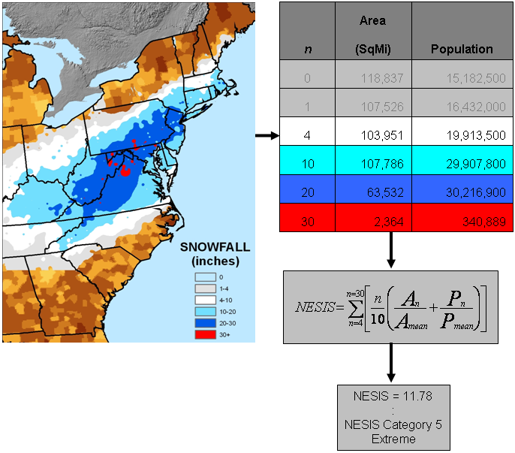
(Fig 1. Shows how the NESIS interprets and categorizes the impact of heavy snowfall along the Northeast corridor.) Source: (Halverson, 2016).

Figure 1 shows these snowstorms have large areas of 10-inch snowfall or greater, and fall under five categories: Extreme, Crippling, Major, Significant, and Notable (Kocin & Uccellini, 2004). Figure 1 has the NESIS scores that are a function of the area affected by the snowstorm, the amount of snow, and the number of people living in the path of the storm (NOAA, 2016). Using GIS data, the “aerial distribution of snowfall and population information are combined in a equation that calculated a NESIS score which caries from around one for smaller storms to over ten for extreme storms” (NOAA, 2016).
One of the main reasons this scale was developed is related to the impact Northeast storms can have on the rest of the country in terms of transportation and economics (NOAA, 2016). The severity of these storms can range from a minor inconvenience for a few days in the northeast, or in the case of Winter Storm Jonas an area of affect that knocked out power for thousands of residents, inflicted around $1 billion in damages, and caused 55 fatalities (Wolter, 2018). What follows is a chronology of the storm which occured January 22 - 23, 2016.

Formation of Winter Storm Jonas
The impact of the storm came from heavy snow, coastal winds and a powerful storm tide (Halverson, 2016).
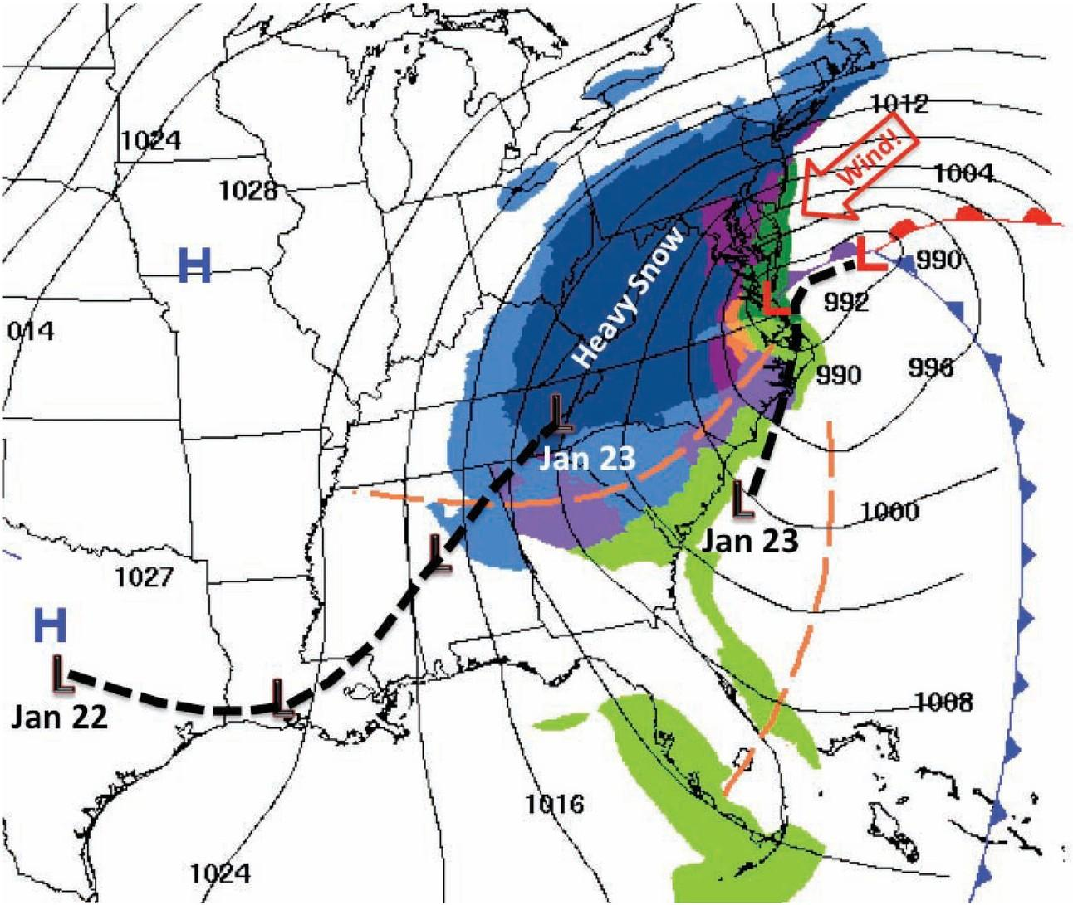
(Fig.2 Surface weather map showing the Nor’easter (red “L”), fronts, and location of the heavy snow band (dark blue region) late in the day on January 23. Earlier track of the storm is shown by black “Ls” and black dotted line.) Source: (Halverson, 2016)

Figure 2 shows the track of the low pressure system sweeping up from Texas along the dotted line of black L’s, where the system reached the southern Appalachians and began to dissipate (Halverson, 2016). A “center jump” from a new low pressure system forming off the coast of Charleston, South Carolina from the weakened system dissipating over the Appalachian mountains and is re-amplified on the east side. Alongside this re-emerging system, a strong high pressure system made its way down from eastern Canada into the Eastern Seaboard. According to Halverson (2016), this freezing air mass became “locked-in” over the Piedmont and Coastal Plain, unable to surmount the mountains (Halverson, 2016). Within this heavy snowband, snowfall rates approached two to three inches per hour at times accompanied by lightning and thundersnow (Halverson, 2016, pp.16). This was the biggest winter storm of 2016 over the eastern U.S., dumping 1m of snow from Virginia to New York, inflicting around $1 billion in damages and caused 55 fatalities (Wolter, 2018).
Winter Storm Jonas
The storm system that impacted the Northeast on January 23, 2016 was known as a Nor’easter, but media outlets referred to it as “Winter Storm Jonas” and “Snowzilla” (Halverson, 2016, pp.14).
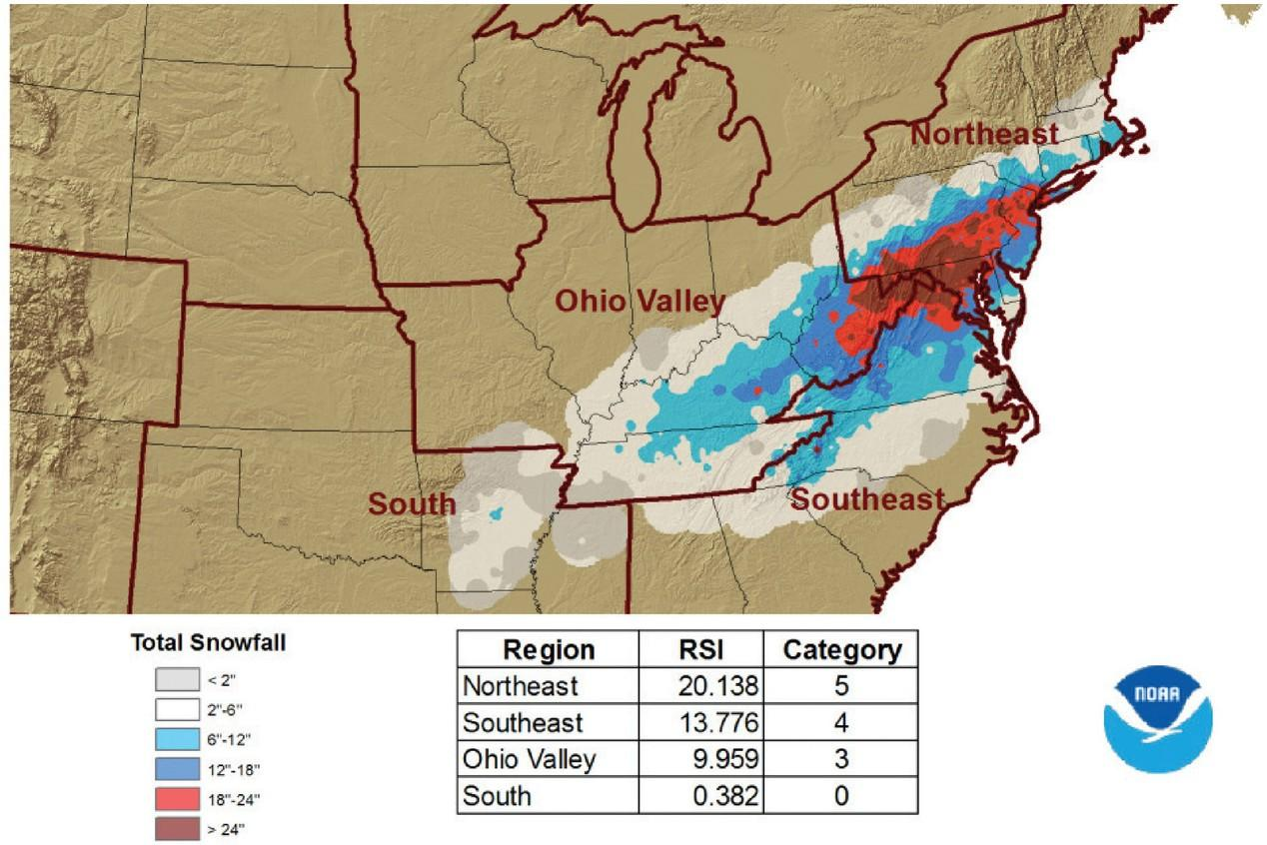
(Fig. 3 Shows the categorizations of the intensity of snow that fell on the Northeast region on January 22 - 23, 2016.) Source: (Halverson, 2016)

The data from Figure 3 shows that the Nor’easter “dumped extreme amount of snow on several major cities, including Richmond, Virginia; Washington, D.C.; Baltimore, Maryland’ Philadelphia, Pennsylvania; Newark, New Jersey; and New York, New York” (Halverson, 2016, pp.15). Winter Storm Jonas was ranked on the NESIS scale as a Category 5 after dumping up too two feet of snow in a band of 18 inches from eastern West Virginia to Long Island, with several pockets within this region reaching three feet (Halverson, 2016).

What caused such a high intensity?
The two most dominant factors that influence U.S. winter storm characteristics are the ENSO and the North Atlantic Oscillation (NAO)/Arctic Oscillation (AO) events (Kunkel et al., 2013, pp. 507). Another major factor for winter storms like Jonas, is the track of El Nino which favors a more southerly storm track and potentially heavy precipitation in the southern states (Kunkel et al., 2013, pp. 507). Jonas was also heavily influenced by “atmospheric blocking”: in the case of Jonas, the air mass approaching from the south from Texas that dissipated over Appalachian, which produced on the east side another low pressure system that became locked in over the eastern seaboard. According to Wolter et al. (2018), internal variations in weather patterns responsible for mid-Atlantic snowstorms have dominated the observed increase of winter storms that were colder than those of the earlier twentieth century.
This observed data is compounded by Halverson (2016), where the Gulf Stream current produced unusually warm ocean water four or five degrees warmer than average for that time of the year. When the air mass broke up and reemerged over the mid-Atlantic, the Gulf Stream current destabilized (became warm and humid), and as this air mass was drawn into the storm center, it energized snowburst-type thunderstorms over the mid-Atlantic. One of the methods that is frequently employed to predict the future of snowstorms is looking at historical data.

The Future from Historical Data
Predicting snowfall for a region is difficult and usual methods rely on historical data and monitoring shifting seasonal weather patterns, mainly: NAO/AO and El Nino events for the southern region of the U.S. But as observed by Kunkel et al. (2012), these trends of what constitutes extreme weather patterns vary regionally. As discussed earlier, NESIS scores are a function of the area affected by the snowstorm, the amount of snow, and the number of people living in the past of the storm (NOAA, 2016). Case in point, snowfall greater than 10 in. is common in many parts of the Northeast and thus often only a short-term inconvenience (Kunkel et al., 2012). While the same snowfall amount in the Southeast might cripple the region for a week or longer.

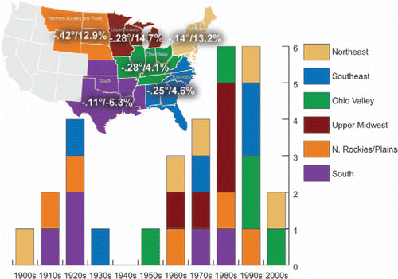
(Fig. 4 Number of extreme snowstorms (upper 10th percentile) occurring each decade within the six U.S. climate regions in the eastern two-thirds of the contiguous U.S.) Source : (Kunkel et al, 2012)

Figure 4 shows there there were more than twice the number of extreme regional snowstorms from 1961 to 2010 (21) as there were in the previous 60 years (9) (Kunkel et al, 2012, pp. 508). Figure 4 also demonstrates extreme storms occurred most frequently in snow seasons that were colder and wetter than average, but not exclusively. Based on Kunkel et al (2012) data, 35 % of snow seasons in which these events occurred were warmer than average and 30% drier than average. Furthermore, data from Wolter, et al. (2018), shows long term observational records produced more heavy snowstorms in recent decades.

Conclusion
While seasonal trends in snowfall accumulation across the mid-Atlantic region are difficult to determine and even harder to predict season to season, the NESIS and RIS are two systems which can give us some information on the future of major snow storms. Winter Storm Jonas led to the deaths of 55 people across the region and hundreds of millions of dollars in losses due to breakdown in transportation services and damages to homes, businesses, and services. Besides the heavy amount of snow dumped across the region, Jonas also produced lightning and thundersnow that crippled the region from the shear intensity of this storm.
The increasing frequency of these storms over the past 50 years have allowed researchers to understand that: although the planet is warming and leading to much drier winter seasons, the impact of these storms are related to warming ocean temperatures from seasonal events like El Nino. Along with the Gulf Stream carrying warmer water in the mid-Atlantic, the northeast region could be facing a future that brings ever increasing winter storms in terms of their intensity and effect on the region.

References
Davis, R. E., & Dolan, R. (1993). Nor’easters. American Scientist, 81(5), 428–439.
Halverson, J. B. (2016). The East Coast Blizzard of 2016: The Northeast Gets Buried. Weatherwise, 69(4), 12–17. https://doi.org/10.1080/00431672.2016.1182846
Kluver Daria, & Leathers Daniel. (2014). Winter snowfall prediction in the United States using multiple discriminant analysis. International Journal of Climatology, 35(8), 2003–2018. https://doi.org/10.1002/joc.4103
Kocin, P. J., & Uccellini, L. W. (2004). A Snowfall Impact Scale Derived from Northeast Storm Snowfall Distributions. Bulletin of the American Meteorological Society, 85(2), 177–194. https://doi.org/10.1175/BAMS-85-2-177
Kunkel, K. E., Karl, T. R., Brooks, H., Kossin, J., Lawrimore, J. H., Arndt, D., … Wuebbles, D. (2012). Monitoring and Understanding Trends in Extreme Storms: State of Knowledge. Bulletin of the American Meteorological Society, 94(4), 499–514. https://doi.org/10.1175/BAMS-D-11-00262.1
Regional Snowfall Index (RSI) | Snow and Ice | National Centers for Environmental Information (NCEI). (n.d.). Retrieved March 18, 2018, from https://www.ncdc.noaa.gov/snow-and-ice/rsi/nesis
Schwartz, R. M., & Schmidlin, T. W. (2002). Climatology of blizzards in the conterminous United States, 1959-2000. Journal of Climate; Boston, 15(13), 1765–1772.
squires-and-lawrimore-2006.pdf. (n.d.). Retrieved from https://www.ncdc.noaa.gov/snow-and-ice/rsi/docs/squires-and-lawrimore-2006.pdf
US Department of Commerce, N. (n.d.). What is a Nor’easter? Retrieved April 23, 2018, from https://www.weather.gov/safety/winter-noreaster
Wolter, K., Hoerling, M., Eischeid, J. K., & Allured, D. (2018). 11. WAS THE JANUARY 2016 MID-ATLANTIC SNOWSTORM “JONAS” SYMPTOMATIC OF CLIMATE CHANGE?, 6.

